|  |  |  |  |
| --- | --- | --- | --- |
| **Report to** | **On** |  | |
| **Scrutiny Committee** | **Tuesday, 13 July 2021** |
|  | |  | |
| **Title** | | | **Report of** |
| **Community Safety Partnership Scrutiny Report** | | | **Director of Communities** |

|  |  |
| --- | --- |
| Is this report confidential? | No |

## Purpose of the Report

1. This report is to provide and overview of the work of the Community Safety Partnership (CSP)

## Recommendations

1. To note the contents of the report

## Reasons for recommendations

1. To provide a challenge to the CSP that they are appropriately responding to community safety issues including those raised by the communities.

## Other options considered and rejected

1. The Scrutiny Committee can call in representatives from the Responsible Authorities on CSPs in order to improve its delivery and hold decision makers to account
2. This report is provided to give an oversight of the ongoing work of the Community Safety Partnership during the pandemic. The report demonstrates the resilience of the CSP and its capability to provide a dynamic response to local needs during a national lock down. The Police have continued to carry out operations to address vehicle, knife and organised crime, despite significant pressures on the neighbourhood policing team, diverted to the covid response.
3. It is noted that overall crime figures have reduced, the identification of vulnerable people in our community has had a significant impact on the case load of the South Ribble Integrated Team, who welcomes the support of the recently appointed Covid Hub Case Managers.
4. Simultaneously, the CSP has continued to support strategic development within reducing reoffending, Prevent agenda and the Domestic abuse bill and the domestic abuse service commissions.

## Corporate outcomes

1. The report relates to the following corporate priorities: *(tick all those applicable):*

|  |  |  |  |
| --- | --- | --- | --- |
| An exemplary council |  | Thriving communities | x |
| A fair local economy that works for everyone |  | Good homes, green spaces, healthy places |  |

## Background to the report

1. The Scrutiny Committee has an opportunity to scrutinise the delivery of the CSP in order to improve outcomes and hold decision makers to account.

**Section 5 of the Crime & Disorder Act 1998**

The Act, established Community Safety Partnerships (CSP) which is an alliance of organisations who generate strategies and policies, implement actions and interventions concerning crime and disorder within their partnership area.

CSPs are statutorily responsible for reducing crime & disorder, substance misuse and re-offending in each local authority area. Each CSP is made up of six ‘responsible authorities’;

* Local Authority
* Police
* Fire & Rescue Service
* National Probation Service (NPS)
* Community Rehabilitation Company (Merged with NPS June 2021)
* Clinical Commissioning Groups

Lancashire is a two-tier authority, of which South Ribble Borough Council and Chorley Council, are neighbouring districts with similar demographic profiles. Therefore, both Chorley and South Ribble Community Safety Partnerships work collaboratively in order to work more efficiently, allowing for better communication, sharing skills, knowledge and project opportunities.

The success of the partnership, is dependent on the collaborative working with Lancashire County Council and the valuable contributions of other partner agencies such as Registered Social Landlords, Drug & Alcohol Services, Citizens Advice Bureau, voluntary community faith sector (VCFS) organisations and commissioned services.

## Overall Position

1. 2020/21 has been an extraordinary year because of the Covid-19 pandemic. The implications have led to resources being diverted to provide resilience in the Covid response, resulting in dynamic deviations often at very short notice. Despite this, the strong and cohesive working relationship of the CSP and wider agencies, has enabled an effective response to community issues during this challenging time.

## Review of Governance and Partnership Arrangements

The Lancashire Community Safety Partnership Board commissioned a review of existing partnership and governance arrangements. The review had a focus on community safety, safeguarding and health and wellbeing. The conclusion of the review provided the option of a Thematic Model and a Geographic Model approach**.**  The view of both South Ribble and Chorley Councils was the Thematic Model would work better. However, a final and collective decision for Lancashire, has yet to made.

## Integrated Offender Management- Reducing reoffending.

The aim of the IOM is to make communities safer by reducing reoffending in order to provide community protection and confidence within the criminal justice system.

This is done by identifying offenders who commit crimes such as burglary, robbery, theft and putting in place effective supervision, by the police offender managers and national probation service. In order to support desistance, rehabilitative pathways are put in place to address the criminogenic need of the individual in order to reduce their likelihood of reoffending.

A dedicated IOM review panel has recently re-established for Chorley and South Ribble in order to target repeat offenders. It is too early to demonstrate its effectiveness locally. However, South Ribble Borough Council and the wider CSP are working together to support the work of the IOM, to reduce the risk of reoffending.

## Prevent

The Counter-Terrorism and Security Act 2015 places a duty on certain bodies to have “due regard to the need to prevent people from being drawn into terrorism”. The Specified Authorities identified in the Act, are Local Authorities, Police, Prisons, Young offender institutions, Probation services, Schools, Colleges, Universities and NHS bodies.

**Local Authority duties under the Prevent Duty Guidance**

• Coordinate Prevent using multi-agency groups.

• Assess risk of at-risk adults and children being drawn into terrorism using Counter Terrorism Local Profiles.

• Develop an action plan to reduce risk to identified vulnerable groups.

• Identify and train staff to recognise radicalisation and extremism.

• Refer identified vulnerable adults and children to Channel where there is an evidence base of risk factors.

• Establish responsible booking policy for public venues.

• Refrain from working with extremist organisations.

The countywide Prevent governance structure (below) was agreed in May 2020. All meetings will provide both Prevent and Channel oversight.

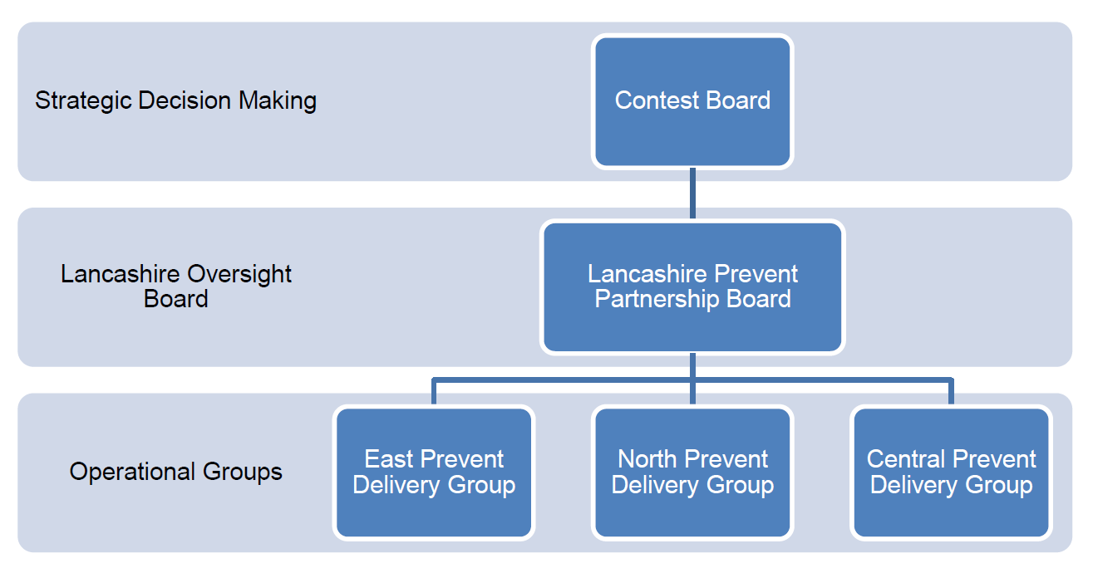

## Community Protection Warnings and Notices

Community Protection Warnings (CPW) is an option when informal measures have been exhausted and Anti-Social Behaviour continues. The CPW, is a formal warning given and is usually the final warning prior to issuing a Community Protection Notice, which if breached could lead to the issue of a Fixed Penalty Notice or prosecution.

From October 2019 – March 2021 the following have been issued for a variety of reasons including (but not exhaustive) dangerous dogs, Japanese knot weed, household waste disposal duty of care etc.

## 51 Community Protection Warning

## 10 Community Protection Notices

## 1 Fixed Penalty Notice

## Office of Police and Crime Commissioner (OPCC)

The May 2021 elections resulted in the appointment of a new Police and Crime Commissioner (PCC) Andrew Snowden.

As a result of successful funding bids to the OPCC (under the guidance of the previous PCC, Clive Grunshaw) the CSP was able to support

* Lancashire wide domestic abuse campaign during the lockdown following the increase in reporting of domestic abuse.
* an awareness campaign for suicide awareness across South Ribble & Chorley
* Camera doorbell campaign (led by the Police) for victims at risk of doorstep crime. This is expected to be rolled out imminently Quarter 2 and 3 of 2021/22

## Domestic Abuse Service Commission

The current contract for the delivery of Commissioned Domestic Abuse service, providing support for high, medium and standard risk victims covering the Lancashire 12 area was let as part of the Lancashire Victim Services contract. This contract ends on 31 March 2022.

The Commissioner and his office have begun the process to recommission victim services in Lancashire from 1 April 2022. It is intended to offer a contract for three years with the option of an extension of a further two years. This would provide a commissioned service for the period 2022/33 to 2026/27 if the extension is activated.

To enable this standard of service to continue the previous Commissioner, Clive Grunshaw, asked Chief Executives to further commit funding for the three years 2022/23 to 2024/25 and continuing to provide £100,000 towards the service in total.

Each district's contribution is based upon their respective population and for South Ribble the contribution requested is £9,082 for each year.

In South Ribble the number of referrals into the service over the life of the current contract is 4,031 reflecting a significant amount of service for the district.

## Domestic Homicide Reviews

South Ribble Borough Council is currently coordinating four Domestic Homicide Reviews (DHR).

*Under section 9(1) of the 2004 Act, domestic homicide review means a review of the circumstances in which the death of a person aged 16 or over has, or appears to have, resulted from violence, abuse or neglect by—*

*(a) a person to whom he****[1]*** *was related or with whom he was or had been in an intimate personal relationship, or*

*(b) a member of the same household as himself.*

It should be noted that an ‘intimate personal relationship’ includes relationships between adults who are or have been intimate partners or family members, regardless of gender or sexual orientation.

Where a victim took their own life (suicide) and the circumstances give rise to concern, for example it emerges that there was coercive controlling behaviour in the relationship, a review should be undertaken, even if a suspect is not charged with an offence or they are tried and acquitted. Reviews are not about who is culpable. *(Multi-agency Statutory Guidance for the Conduct of Domestic Homicide Reviews, 2016*)

## South Ribble Integrated Team (SRIT)

April 2020 until March 2021

The South Ribble Integrated Team have received 108 referrals. These cases have been for families and individuals with multiple complex needs such as hoarding, declining mental health, loneliness, isolation, substance misuse, homelessness, financial issues and bereavement. The SRIT has worked in partnership to provide support and intervention, together they have closed 91 cases within the 12-month period, with 15 cases being supported past March 2021 and 2 cases escalated to Lancashire County Council Safeguarding Team.

In recent months the SRIT has had the added support of the SRBC Covid Hub Case Managers ( similar to a social prescriber function). This has enabled SRIT to offer more intensive support to those who otherwise to engage with services without further encouragement. The model has worked well, with each plan tailored to the needs of the individual, it provides them with the right level of contact and encouragement while also empowering them to take responsibility for completing actions themselves to improve their own situation. (a short case study can be made available if required)

**Multi-Agency Risk Assessment Conference (MARAC)**

A MARAC listing high risk cases of domestic abuse is held each month. The multi-agency meeting facilitates the sharing of up to date information. Actions are put in place in order to safeguard the victims, children and other vulnerable members of the household.

The most up to date figures for the Chorley & South Ribble MARAC shows that between April 2020 -March 2021

* 262 Cases were discussed
* -18% Year on year changes (possibly due to the introduction of a further screening process prior to the meeting)
* 453 Children in the household
* 0 Victims aged 16-17
* 0.0 % Declared having a disability
* 4.2 % Males

## Lancashire Violence Reduction Network (LVRN)

Lancashire Violence Reduction Network is made up of several partners from across public services and the third sector. The aim of the network is to facilitate a system wide trauma informed approach to preventing and tackling the root causes of serious violence. The LVRN will support the CSPs in their approach to prevent serious violent crime.

## Lancashire Police Data (See appendix for full Police analyst report )

A total of 6115 crimes were recorded in South Ribble during the 2020/21 financial year.

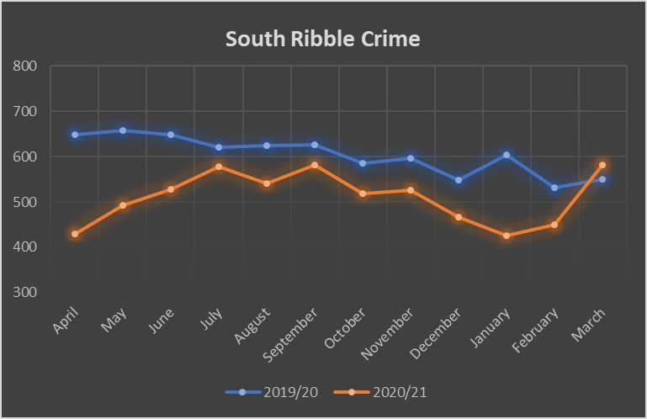

This is a year to date decrease by 15.6% (n=1128) compared to the 7243 crimes recorded during the 2019/20 financial year. This decrease is highly like due to the government imposed COVID-19 regulations with the lockdown restrictions providing less opportunity for certain crimes such as Theft, which has shown the largest year to date decrease by 36.5% (n=455).

The top ward for all recorded crime in 2020/21 was Middleforth ward (9.0%, n=550) followed by Leyland Central (7.7%, n=468) and Seven Stars (7.5%, n=459).

**Anti Social Behaviour**

The below table breaks down the total number of anti-social behaviour incidents by month for the 2020/21 financial year as well as providing an annual percentile breakdown. This reveals that the highest number of ASB incidents was recorded during April 2020 with 651 incidents, closely followed by March 2020 with 631 incidents.

|  |  |  |  |  |  |  |
| --- | --- | --- | --- | --- | --- | --- |
| **MONTH** | **TOTAL ASB** | | **COVID** | | **YOUTH** | |
| **Number** | **%** | **Number** | **%** | **Number** | **%** |
| **Apr-20** | 651 | **12.9%** | 233 | **35.8%** | 124 | **19.0%** |
| **May-20** | 631 | **12.5%** | 326 | **51.7%** | 84 | **13.3%** |
| **Jun-20** | 364 | **7.2%** | 62 | **17.0%** | 74 | **20.3%** |
| **Jul-20** | 363 | **7.2%** | 19 | **5.2%** | 78 | **21.5%** |
| **Aug-20** | 386 | **7.7%** | 35 | **9.1%** | 66 | **17.1%** |
| **Sep-20** | 342 | **6.8%** | 41 | **12.0%** | 77 | **22.5%** |
| **Oct-20** | 457 | **9.1%** | 60 | **13.1%** | 145 | **31.7%** |
| **Nov-20** | 334 | **6.6%** | 41 | **12.3%** | 66 | **19.8%** |
| **Dec-20** | 279 | **5.5%** | 52 | **18.6%** | 49 | **17.6%** |
| **Jan-21** | 362 | **7.2%** | 77 | **21.3%** | 36 | **9.9%** |
| **Feb-21** | 392 | **7.8%** | 79 | **20.2%** | 59 | **15.1%** |
| **Mar-21** | 477 | **9.5%** | 65 | **13.6%** | 99 | **20.8%** |
| **Total** | **5038** | **100.0%** | **1090** | **21.6%** | **957** | **19.0%** |

The top wards for anti-social behaviour incidents during 2020/21 were Middleforth (8.59%, n=433), Leyland Central (6.73%, n=339) and Seven Stars (6.65%, n=335).

**Domestic Abuse**

The below table provides a gender breakdown of recorded victims of Domestic Abuse crime for 2019/20 and 2020/21 financial year. This reveals that the percentile breakdown for both years is similar, although for 2020/21 a slight percentile increase for male victims is recorded compared to the previous year.



**Violence Against the Person**

During the 2020/21 financial year a total of 2827 Violence Against the Person offences were recorded in South Ribble which is a minor year to date decrease by 3.2% compared to 2920 offences recorded during the previous financial year.

The most common ward for violence with injury was Seven Stars (10%, n=71) followed by Broadfield (8.9%, n=63) and Bamber Bridge West (7.9%, n=56).

**Hate Crime**

A total of 104 hate related crimes were recorded during 2020/21 financial year which is the same number as recorded during the previous year. Figures fluctuate throughout the year with September recorded the highest number (n=14), followed by July and November which both recorded 12 hate crimes.

More than half of hate crimes were **racist** in nature (n=61), with 28 relating to **sexual orientation** and 14 linked to **disability**. Additionally, four referenced **religion** and four offences were recorded as **transgender** hate crime.[2]

**Knife Crime**

Within the 2020/21 financial year 0.98% (n=60) of all recorded crime within South Ribble was classed as knife crime. This is both a minor percentile and numerical increase compared to 0.77% (n=56) recorded during 2019/20 financial year

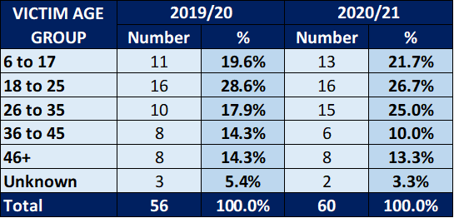

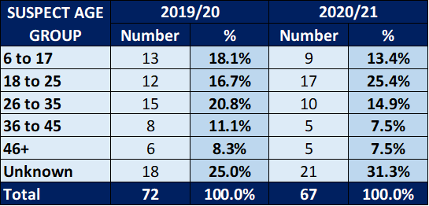

**Police Update**

**Leyland Police Station**

Work continues to prepare Leyland for the reintroduction of immediate response officers and utilisation as a briefing base. Neighbourhood Policing Team officers and supervision will remain and be further supported by immediate response supervision and officers on a 24/7 basis. It is anticipated that the preparatory building and estates work will be completed early 2022 and the officers will move into the station around spring 2022.

**Covid**

COVID continues to present a challenge operationally to police. As restrictions have now eased the issuing of Fixed Penalty Notice tickets which were commonplace in the previous lockdowns are now not as common. Significant work was undertaken with licensed premises and similar ahead of the easing of the restrictions and despite some notable issues there has been a smooth transition back to regular openings particularly within the licensing trade. Dedicated policing of Covid breaches using “ringfenced” resources has now ended and any COVID breaches are dealt with by the existing response structures.

**Police Operations**

Crime prevention – catalytic converter theft marking kits – obtained through LANPAC funding – provided free to previous victims and owners of targeted vehicles. Local car dealership has agreed to put the kits on a vehicle and are asking for a £10 donation to charity – part of a national crime trend – crime prevention details shared. Regional information sharing established around travelling criminals.

**Anti Social Behaviour (ASB) motorcycle nuisance**

Operation seizure – direct reporting by public/target used to tackle ASB. Reduced demand through force control room. Allows NHPT staff to contact witness directly and target their activity in real time. Numerous bike seized/persons reported for motoring offences.

**Theft/ASB**

Motorway service areas – working with National Crime Agency (NCA) and National Vehicle Crime Intelligence Service (NaVCIS) – members of a national Organised Crime Group (OCG) being prosecuted and working other forces around similar prosecutions. Crime prevention/designing out crime completed including working national companies - minimal crime reported now and details shared within the county. Applied both to M6/M61.

**Operation Chasity 2**

Winner of Lancashire Constabulary shrievalty award this year – supporting vulnerable members of the community from exploitation.

**Task Force**

Increased use of the local task force officers to support and assist Community Beat Managers (CBMs) with areas. Task force have obtained numerous warrants and assisted in targeted activity in Chorley and South Ribble districts; disrupting offenders and assisting with development of intelligence.

**Four Operation Oryx completed**

County response to car cruise events. Trialled in Chorley and refined to the finish product now used across the county.

**Tasking Meetings**

Weekly tasking meeting extended to include early action teams and Youth Offending Teams to maximise opportunities to target and support repeat VOLs., reducing demand and protecting the most vulnerable.

**Lancashire Talking**

Community engagement through In the Know Messaging, Lancashire Talking and Social Media – both districts continue to improve, and it is part of daily business. Continued focus on engagement strategy as we emerge from lockdown to target those communities who may not be “online”.

## The Future

## Domestic Abuse Bill

## The Domestic Abuse Bill received Royal Ascent April 2021. There is a duty on Tier 2 districts, borough and city councils and London Boroughs to co-operate with Tier 1 authorities. Tier 1 authorities should finalise and publish their first strategy, based on a robust needs assessment, by August 2021

**Four main objectives of the Domestic Abuse Bill:**

* **promote awareness** – to put domestic abuse at the top of everyone’s agenda, and raise public and professional awareness
* **protect and support** – to enhance the safety of victims and the support that they receive
* **transform the justice process** – to prioritise victim safety in the criminal and family courts, and review the perpetrator journey from identification to rehabilitation
* **improve performance** – to drive consistency and better performance in the response to domestic abuse across all local areas, agencies and sectors

## Serous Violent Crime Bill

## This has been further delayed and is due to receive Royal Ascent in January 2022 and to become law around July 2022.

## This will impose a duty on district councils and other statutory agencies to understand their local issues, prepare and implement a strategy.

## The LVRN will offer leadership and strategic coordination working with CSPs in their local response to serious violence.

## Strategic Assessment

## The three-year strategic assessment which Identifies Lancashire and local priorities is currently being developed and will inform the three-year plan for CSPs. This is due to conclude November 2021

## Risk

1. The unknown outcome and impact of the Lancashire Community Safety Partnership Boards review. Being organisationally ready to meet the requirements of the Domestic Abuse Bill, Serious Violent Crime Bill and the growing CSP agenda.

## Equality and diversity

1. N/A.

## Air quality implications

1. None

## Comments of the Statutory Finance Officer

1. None

## Comments of the Monitoring Officer

1. The enabling legislation of the CSP’ being the Crime and Disorder Act 1998 and other statutory duties of the council relevant to the CSP are referred to in the body of the report.

Jennifer Mullin

Director of Communities

|  |  |  |  |
| --- | --- | --- | --- |
| Report Author: | Email: | Telephone: | Date: |
| Heather Corson (Community Safety and Safeguarding Manager) | heather.corson@southribble.gov.uk | 01772 625577 | 5 July 2021 |

1. Section 6 of the Interpretation Act 1978 - words importing the masculine gender includes the feminine.
2. Please note, some offences recorded more than one hate type.